

2025


This template can be used for multiple purposes:
by:
- It enables schools to effectively plan their use of the Primary PE and sport premium
- It helps schools to meet the requirements (as set out in guidance) to publish information on their Primary PE and sport premium
- It will be an effective document to support Ofsted inspections enabling schools to evidence progress in Physical Education (PE) and evidence swimming attainment, which forms part of the PE National Curriculum. We would recommend schools consider
the Intent, Implementation and Impact of any spend, as examined within the Education Inspection Framework.

It is important that your grant is used effectively and based on school need.

Schools must use the funding to make additional and sustainable
improvements to the quality of the PE, School Sport and Physical Activity (PESSPA)
they offer. This means that you should use the Primary PE and sport premium to:

- Build capacity and capability within the school to ensure that improvements made now will benefit pupils joining the school in future years
- Develop or add to the PESSPA activities that your school already offers.

The Primary PE and sport premium should not be used to fund capital spend projects; the school’s core budget should fund these. Further detail on capital expenditure can be found in the updated Primary PE and sport premium guidance.

The Primary PE and sport premium guidance, outlines 5 key priorities that funding should be used towards. It is not

necessary that spending has to meet all the key priorities, you should select the priorities that you aim to use any funding towards.

Although completing this template is not a requirement for schools, schools are required to publish details of how they spend this funding. Schools must also outline what the impact this funding has had on pupils’ PE and sport participation and attainment and how any spending will be sustainable in the future.

The Department for Education has worked closely with the Association for Physical Education (afPE) and the Youth Sport Trust (YST) to develop this template and encourages schools to use it. This template is an effective way of meeting the reporting requirements of the Primary PE and sport premium.

Key priorities and Planning
This planning template will allow schools to accurately plan their spending.

Action – what are you planning to do | Who does this action impact? | Key indicator to meet | Impacts and how sustainability will be achieved? | Cost linked to the action
Use specialist sports coaches (Activ360) who will train staff giving them the knowledge needed to encourage and teach children to take part in different sporting activities. | This will develop the PE skills with teaching staff and LSA’s in a range of sporting activities. Give a broad and balanced PE curriculum which will enable children to take part in a range of sporting activities.  EYFS/KS1/KS2 will receive 1 hour of tuition per week. | Key Indicator 1  Key Indicator 3 | More pupils meeting their daily physical activity goal, more pupils encouraged to take part in PE and Sport Activities. | Activ 360 (Curriculum and club time)
Use specialist coaches (Activ360) to deliver sports coaching through delivery of after school clubs.  80% of KS2 pupils to attend at least 1 after school sports club. | Pupils will experience a broader range of sporting activities. Pupils will meet at least 1.5 hours of activity in the week.  Have targeted provision for those least active pupils. Minimum take up of at least 15% from those identified as least active at the start of the academic year. | Key Indicator 4 | More pupils encouraged to participate in a wider range of sporting activities. Pupil conference children not engaging with after school sports clubs.
Use specialist coaches (Andover Leisure Centre) to deliver swimming sessions to children not meeting Y6 expectations for swimming. | Pupils will increase levels of confidence and skills required to progress towards swimming 25m. | Key Indicator 1 | Y6 Meeting National Expectation Targets for swimming. | £ (swimming coaches and hire of pool)  £ (Transport to Andover Leisure Centre)
Participate in 6 Intra-school sports festivals and 6 Inter school sports festivals. 80% of KS2 pupils to represent Hurstbourne Tarrant in an Inter-School Festival. Include a B team in at least two festivals. |  | Key Indicator 5  Key Indicator 1  Key Indicator 2 | Wider range of children will be encouraged to participate in sporting activities.
Train and engage wider school staff in the delivery of school sport and physical activity in areas such as gymnastics and dance. Engage with Basingstoke and Deane Sports Partnership (Phil Jeffs) to provide CPD opportunities. | Teaching staff will display improved levels of confidence in the delivery of gymnastics and dance. | Key Indicator 3 | Staff will be encouraged to put training into practice and deliver effective gymnastic and dance sessions. | £500 (School Sports Partnership)
School Council to comment on and influence provision of physical activity. | School Council and the wider student body will be encouraged to speak with confidence about PE and Games at Hurstbourne Tarrant. | Key Indicator 2  Key Indicator 4 | Children of school council will pupil conference their peers with regards to availability of sports provision at the school and how it could be enhanced.
To provide road safety awareness and training for Y6 pupils in developing their cycling skills. (Bikeability) | Y6 pupils will participate in a two day programme which encourage children to maintain good cycle management, road safety awareness and rider confidence. | Key Indicator 1  Key Indicator 4 | Y6 pupils will receive accreditation certificates at different levels as a result of their participation. Level 1 is bike confidence. Level 2 is road confidence. | No cost to school.

Key achievements 2025-2026
This template will be completed at the end of the academic year and will showcase the key achievements schools have made with their Primary PE and sport premium spending.

Activity/Action | Impact | Comments

Swimming Data
Meeting National Curriculum requirements for swimming and water safety.
Priority should always be given to ensuring that pupils can perform safe self-rescue even if they do not fully meet the first two requirements of the National Curriculum programme of study

Question | Stats: | Further context  Relative to local challenges
What percentage of your current Year 6 cohort can swim competently, confidently and proficiently over a distance of at least 25 metres? | % | Use this text box to give further context behind the percentage.  e.g., 30% - we are struggling to get pool space due to our local pool closing so we have had to use a much smaller local school pool. We have had to limit the number of pupils attending swimming lessons during one term which means some pupils have attended fewer swimming lessons than others.
What percentage of your current Year 6 cohort can use a range of strokes effectively [for example, front crawl, backstroke, and breaststroke]? | % | Use this text box to give further context behind the percentage.  e.g., Even though your pupils may swim in another year please report on their attainment on leaving primary school at the end of the summer term 2024

What percentage of your current Year 6 cohort are able to perform safe self-rescue in different water-based situations? | % | Use this text box to give further context behind the percentage.

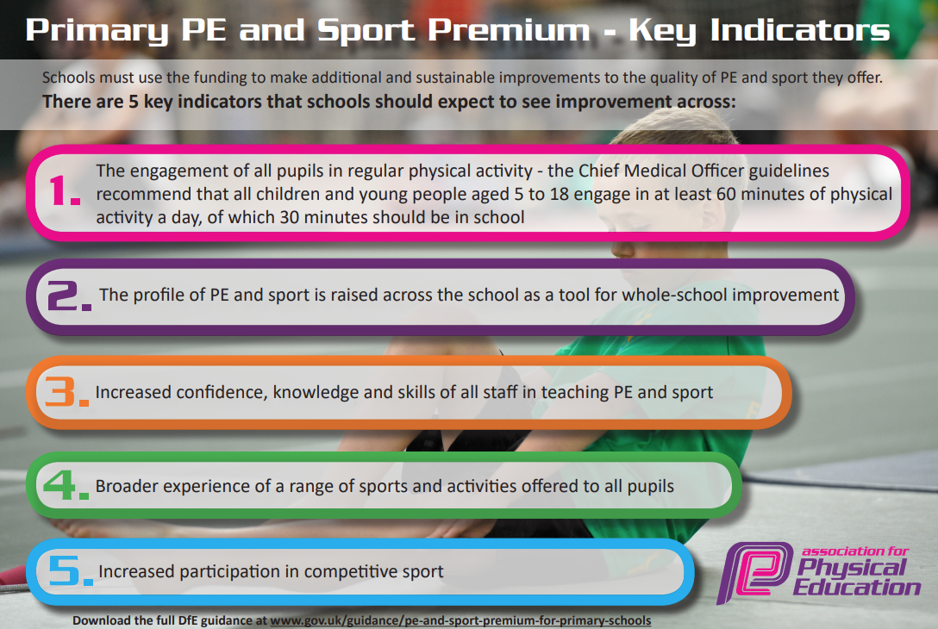

Signed off by:

Head Teacher:
Subject Leader or the individual responsible for the Primary PE and sport premium: | R Price
Governor:
Date: September 2024

