Hurstbourne Tarrant Church of England Primary School
Is your child due to start school
in September 2027?

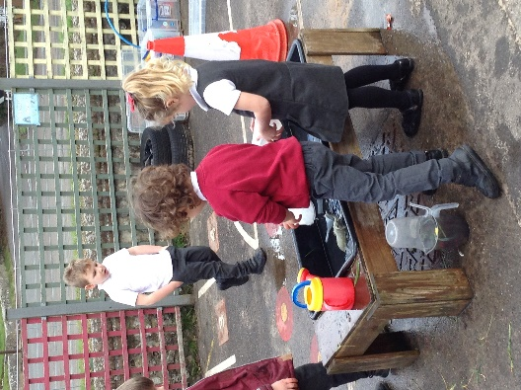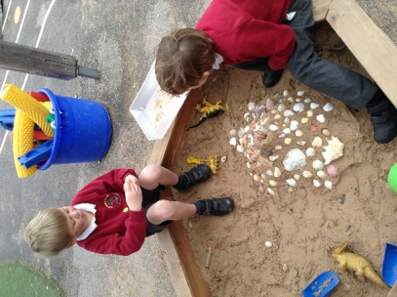
Why not take a look at Hurstbourne Tarrant Primary School!
Hurstbourne Tarrant Church of England Primary is a forward thinking, friendly village School. We recognise the importance of starting school and aim to nurture each and every one of our pupils. Ofsted (May 2025) commented that: ‘Pupils benefit from warm and trusting relationships with staff … right from the start in the early years, the school promotes children’s confidence and resilience. It provides pupils with many opportunities to develop their interests and explore their talents.’
Why not come and visit us? We have two open afternoons on Thursday 22nd October 2026 and Thursday 19th November 2026 where you can see the school in action anytime between 1:30pm and 3pm. If you can’t make this time, you can phone the school office on 01264 736213 and book a tour at your convenience.

